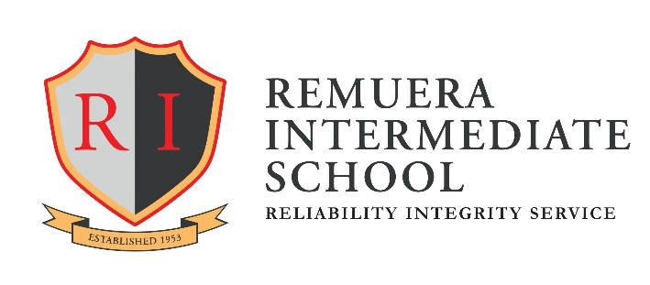
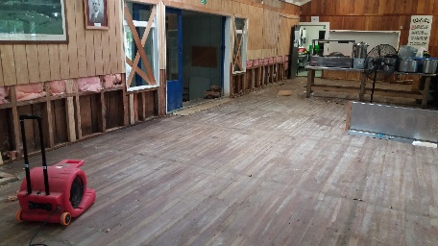
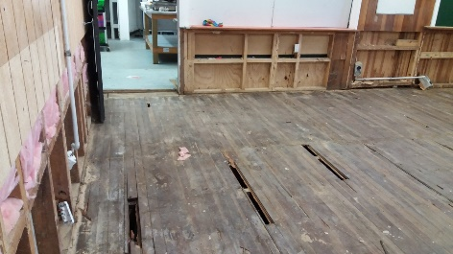
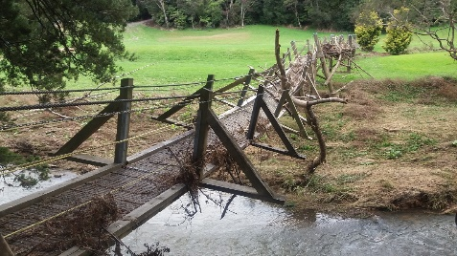
Year 7 Camp Adair 2017 Cancelled
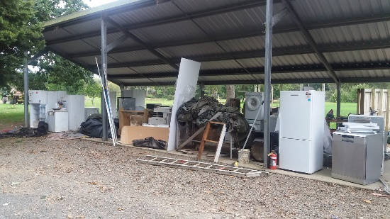

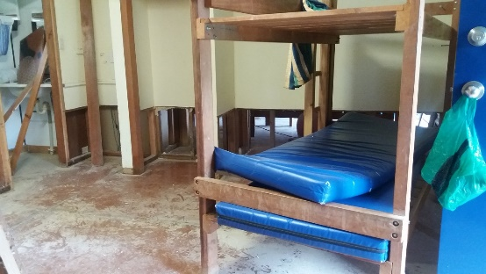

Despite the best efforts of the Camp Adair Staff to try and get the camp up and running, they have informed us that we will have to cancel our visit.
The recent flood caused significant damage and they are not able to guarantee the full use of the facilities. There may be some problems with safety and hygiene.
After all the excitement of organising and preparing, it is difficult for all of us to face this disappointment.
There will be no camp meeting for parents in the school hall this Wednesday, 22 March.
Thank you to those parents who have paid promptly, our office staff will be organising refunds. Watch for updates on the school website.
We are grateful to all the parents who offered to come out to camp and assist us. We hope that you will take up the opportunity to join next year’s camp.

Best regards,

Kyle Brewerton (Principal) Robert Rasmussen (Head of Year 7)

